Democratic Women of the Southern Tier and Finger Lakes
Needs Assessment
September 27, 2013

One of our organizational goals is to get more Democratic women elected to office in the Southern Tier and Finger Lakes regions of New York.

As with any campaign, it is important first to understand the current lay of the land, and what we have to achieve in order to succeed. Numerically speaking, how disproportionately represented are Democratic women right now? Once we understand that, we can set ambitious and achievable objectives, measure our progress, and determine whether our strategies for getting more Democratic women elected to office are working.

We are compiling a county-by-county Needs Assessment of the following counties: Allegany, Cattaraugus, Cayuga, Chautauqua, Chemung, Cortland, Ontario, Schuyler, Seneca, Steuben, Tioga, Tompkins, and Yates.

Our Assessment compiles all the elected offices and their current occupants, in each county, to determine each office holder’s gender and party affiliation. With that data for each county, we can analyze the data and craft strategies to help elect more Democratic women that are tailored for each jurisdiction in each county, rather than a one-size-fits-all approach.

Our full data assessment will not be complete until we know the results of this election cycle in November, 2013. However, the following are interesting data points that we know already:

BREAKDOWN OF CURRENT COUNTY LEGISLATORS & SUPERVISORS
210 officeholders across 13counties

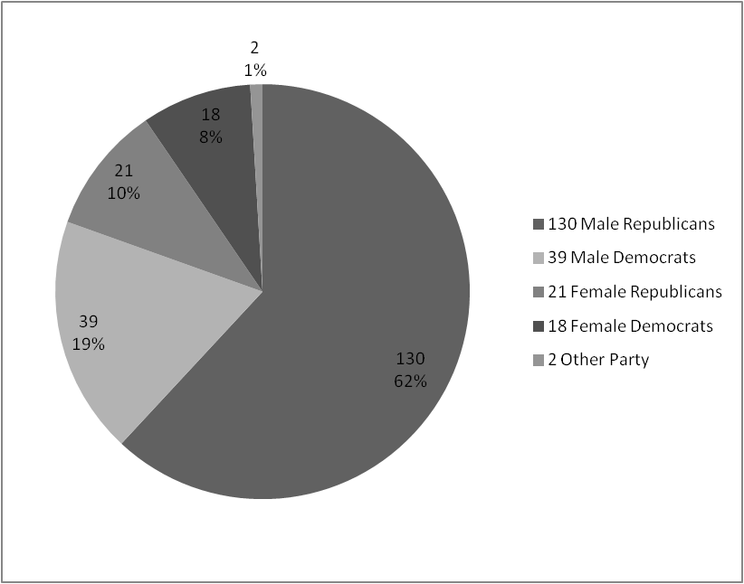

RATE OF WOMEN ON THE DEMOCRATIC LINE IN A SAMPLING OF COUNTIES
In the November 2013 Election

County | Number of candidates running | Number of candidates who are women running on the D line | % of candidates who are women running on the D line
Cattaraugus | 85 | 25 | 29%
Chautauqua | 199 | 34 | 17%
Chemung | 67 | 3 | 4%
Steuben | 215 | 20 | 9%
Tompkins | 117 | 32 | 27%
Yates | 62 | 0 | 0%

NEXT STEPS:

With the analysis of the County Legislators and Supervisors above, we will continue the county-by-county Needs Assessment for the rest of the offices within the Southern Tier and Finger Lakes regions, first by determining all the elected offices in each county and the gender of the current holder of each office. Following that, we will research the party affiliation of each elected official. Elected positions in any given county include all types: Town Board Member, Highway Superintendent, Sheriff, Legislator, Judge, County Executive and others.

So far we are learning that counties in the Finger Lakes and Southern Tier have widely divergent rates for women holding political office. In addition, a greater quantity of elected positions does not translate into a higher rate of women holding office.

Once the county-by-county Needs Assessment is complete, we will set goals and work with supporters in each county to strategize on the best ways to elect women to particular offices.

